MPU6050 Accelerometer Offset & Scale Correction Instructions

Background:
The MPU6050 does not read data perfectly due to flaws in the manufacturing of the unit as well as imprecise tooling in the fabrication of a toy_11 interface. These instructions will help users correct constant bias (offset) and gain error (scale) in the MPU6050 accelerometer so that measured acceleration accurately reflects real-world values. Simply put, when the toy_11 box is resting on a flat surface in a given orientation, the MPU should be reading a value of either 1g or -1g along one of its axes (X, Y, or Z), and 0g along the other two. This procedure corrects both offset and scaling errors with the goal of achieving a less than 5% margin.

Procedure:
- Open the included secrets.h file that corresponds with the Arduino files installed on your device:

/* GLOBAL VARS */
#define SECRET_SSID "NETGEAR63" // WiFi SSID
#define SECRET_PASS "joyoustable416" // WiFi password
// #define PLAYER_ADDR "/player1/" // Update the player number according to your need and number of players.
#define LOCALPORT 8000 // Some local port (make sure it's the same on Max in the host machine)
#define DESTINATION_IP "192.168.1.2" // Target Computer Destination. See documentation for setting static IP address reservation for host computer
#define MPU6050_TCA_ADDR 4
#define APDS_TCA_ADDR 5
#define TOF1_TCA_ADDR 6
#define TOF2_TCA_ADDR 7

/* MPU6050 Accelerometer Offset & Scaling Adjustments */
#define X_MAX 1.047;
#define X_MIN -.944;
#define Y_MAX .997;
#define Y_MIN -1.012;
#define Z_MAX .876;
#define Z_MIN -1.186;

- Change all the values in the MPU 6050 Accelerometer Offset & Scaling Adjustments section to:

/* MPU6050 Accelerometer Offset & Scaling Adjustments */
#define X_MAX 1.0;
#define X_MIN -1.0;
#define Y_MAX 1.0;
#define Y_MIN -1.0;
#define Z_MAX 1.0;
#define Z_MIN -1.0;

- Load the Arduino file onto your toy_11 interface via the USB port.

- Disconnect the toy_11 interface from your computer, close it, place it on a level surface, and run it normally over WiFi. The floor is most often the most level surface if you are unsure about your table, but conducting this process on the table that you will be performing on will be the most accurate.

- Connect your computer to the same WiFi router as the toy_11 interface. Be sure that the DESTINATION_IP variable is set correctly in the Arduino file. See setup instructions or troubleshooting files for more details.

- Open the toy_11_API.maxpat file and open the sub patch associated with your player number. You should see a stream of data incoming from the toy_11 interface.

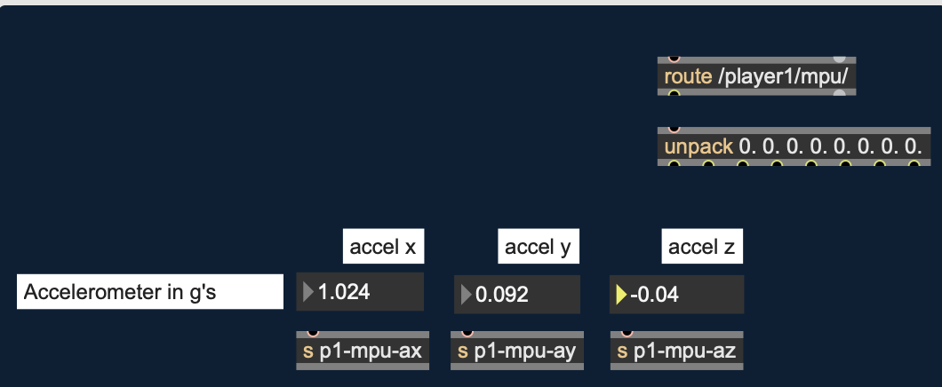
- With each side of the toy_11 interface facing up, update the corresponding MIN/MAX values in the secrets.h file to the approximate, most stable value for each minimum or maximum on display. Remember, for each side, only one dimension of acceleration be close to 1g or -1g, that is the value you update. In the example above, accel x is reading 1.024 consistently, so you would update the X_MAX value from 1.0 to 1.024.
- Once all adjustments have been made, reconnect the toy_11’s Arduino to your computer and upload the updated files to the interface.
- Run the toy_11 interface once more, and check that the offset and scaling error is less than 5%.

